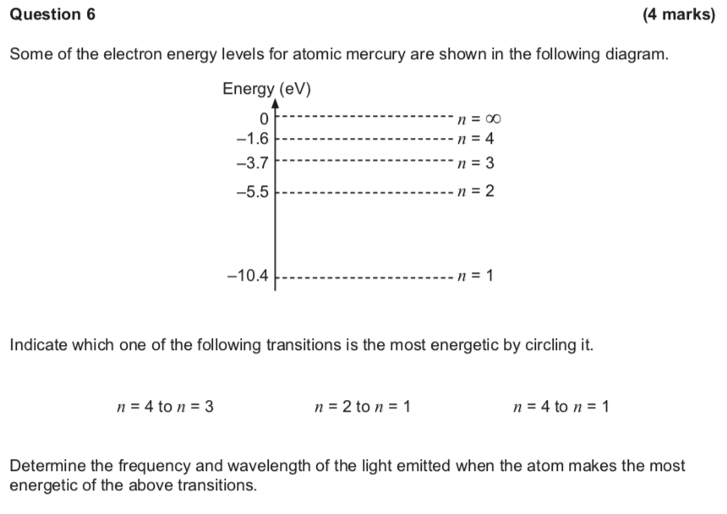

**Question 14 (12 marks)**

An electron microscope creates a coherent beam of electrons which then travels through two narrow slits. The resulting interference pattern is detected on a photographic plate. The speed of the electrons is 1.00% of the speed of light.

(a) Show that the de Broglie wavelength of the electrons used is 2.43 × 10-10 m.

(2 marks)

(b)  Describe what you expect to see on the photographic plate.

(c)  Explain the behaviour of the electrons in this experiment.

(2 marks)

(2 marks)

**15**

**PHYSICS**

(d) If the experiment were to be repeated using protons, at what speed would a proton need to travel to have the same de Broglie wavelength as the electrons? (2 marks)

Answer m s-1

(e) Calculate the potential difference required for the electron microscope to accelerate the

electrons to 1.00% of the speed of light. (4 marks)

**Question 20**

**(16 marks)**

A light beam is directed toward a metal surface and electrons are ejected from it. The wavelength of the incident beam is varied between 238 nm (ultraviolet) and 464 nm (green). The maximum kinetic energy of the ejected photoelectrons is measured and recorded in the table below.

(a) Complete the following table by calculating the missing energy of the incident photons for each wavelength. Show your working in the space below. (2 marks)

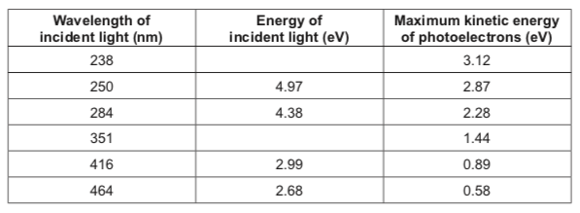

(b)   Plot the data from the table above on the grid provided, demonstrating the relationship between the energy of the incident photons on the horizontal axis and the maximum kinetic energy of photoelectrons on the vertical axis. Draw the line of best fit. (4 marks)

(c)   Using your graph, determine the work function of the metal. Express your answer in appropriate significant figures and include units. (4 marks)



(d) Explain how the failure of red light to cause the emission of electrons demonstrates the

particle nature of light. (3 marks)

(e) In this photoelectric effect investigation, light is best described as a particle. There are other characteristics that demonstrate light to be a wave. State **one** such characteristic and describe how this demonstrates wave behaviour. (3 marks)

**Question 5**

**5 PHYSICS (4 marks)**

An LED can emit three different colours with three different temperatures (K), i.e., 3000 K (warm white), 4000 K (natural white) and 6000 K (white), with three different radiation energies, *U*3000 K, *U*4000 K and *U*6000 K respectively.

(a) If the intensity is the same for each colour, then the relative electrical energy consumption

(*U*) for each colour is

(1 mark)

A *U*3000 K > *U*4000 K > *U*6000 K.

B *U*3000 K = *U*4000 K = *U*6000 K.

C *U*3000 K < *U*4000 K < *U*6000 K.  
D There is no correlation in terms of energy consumption.

(b)  Which LED emits the greatest proportion of long wavelength radiation?

A  3000 K (warm white)

B  4000 K (natural white)

C  6000 K (white)

D  They are all the same.

(c)  Which LED emits the greatest proportion of high frequency radiation?

A  3000 K (warm white)

B  4000 K (natural white)

C  6000 K (white)

D  They are all the same.

(d)  Which LED emits the greatest proportion of fast photons?

A  3000 K (warm white)

B  4000 K (natural white)

C  6000 K (white)

D  They are all the same.

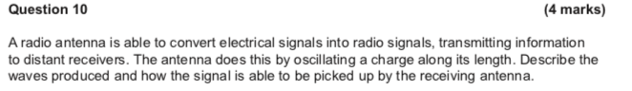

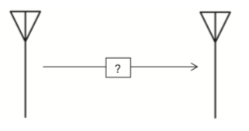

**Question 12**

**13 PHYSICS**

**(5 marks)**

Describe the characteristics of a black body and use the black body radiation curves shown below to explain why the concept of light quanta was necessary.

